**Admin User Journey for E-commerce System**

**Key Scenarios:**

**Tenant Management:**

* Add the tenant and select (store or restaurant)

**Product Management:**

* Admin can add, update, and remove products.
* Admin can categorize products and manage stock availability.

**User & Address Management:**

* Admin can view and manage user accounts and their addresses (shipping & billing).
* Admin can assign user roles, such as customer, seller, or manager.

**Order Management:**

* Admin can view all orders, including their payment method (COD, advance) and status.
* Admin can update order status from pending to shipped, delivered, or canceled.
* Admin can see the associated shipping and billing addresses for each order.

**Payment Tracking:**

* Admin can track payments by method (COD, card, advance) and their status (pending, paid).
* Admin can manage refunds if an order is canceled.

**Reporting & Analytics:**

* Admin can generate reports for sales, payments, and user activity.
* Admin can filter reports by payment method, or date range.

**ERD**

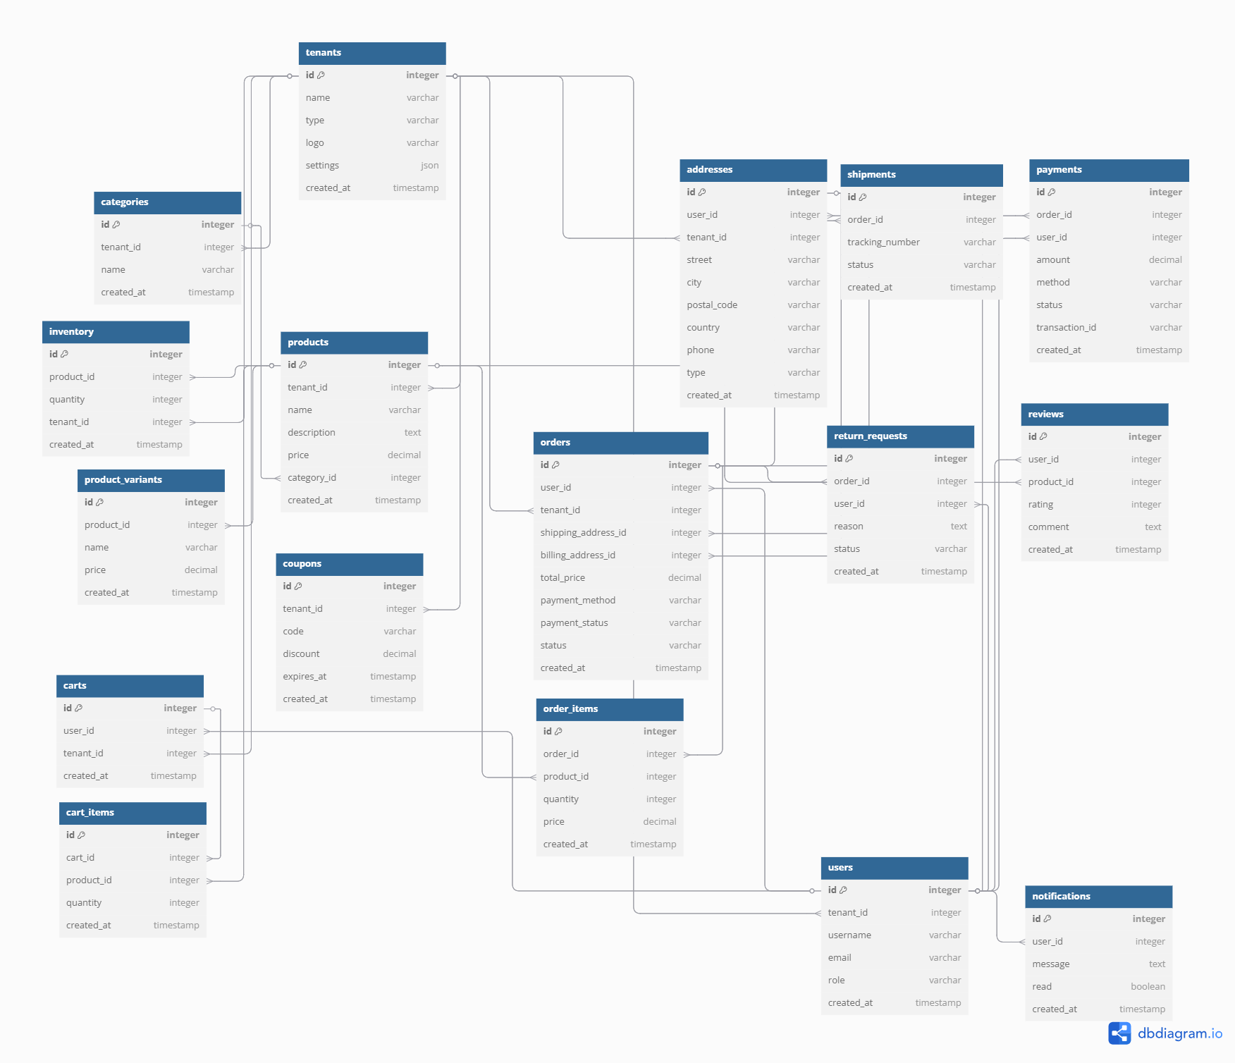

Product & Product Translation Model Documentation

# Product Model

Below are the fields for the `product` model, including required attributes and descriptions:

|  |  |  |  |
| --- | --- | --- | --- |
| **Field** | **Type** | **Description** | **Required** |
| id | INTEGER | Primary key, auto-incremented | Required |
| sku | STRING | Stock Keeping Unit identifier | Optional |
| slug | STRING | Unique slug for the product | Required |
| cost_price | FLOAT | Cost price of the product | Required |
| stock | INTEGER | Stock quantity available | Required |
| sale_price | FLOAT | Selling price of the product | Required |
| discount_percentage | FLOAT | Optional discount percentage | Optional |
| thumbnail | STRING | Thumbnail image URL | Required |
| images | ARRAY of STRING | List of product image URLs | Optional |
| is_featured | BOOLEAN | Flag if the product is featured | Default: false |
| meta_title | STRING | Meta title for SEO | Required |
| meta_description | TEXT | Meta description for SEO | Required |
| user_id | INTEGER | ID of the user who added the product | Optional |

## Sample Product Object

{  
 "id": 1,  
 "sku": "PRD-001",  
 "slug": "classic-white-shirt",  
 "cost_price": 15.99,  
 "stock": 120,  
 "sale_price": 25.99,  
 "discount_percentage": 10.0,  
 "thumbnail": "https://example.com/images/products/shirt-thumbnail.jpg",  
 "images": [  
 "https://example.com/images/products/shirt-front.jpg",  
 "https://example.com/images/products/shirt-back.jpg",  
 "https://example.com/images/products/shirt-side.jpg"  
 ],  
 "is_featured": true,  
 "meta_title": "Classic White Shirt | Men’s Clothing",  
 "meta_description": "Buy the classic white shirt for men. Perfect for formal and casual events. Premium cotton with a comfortable fit.",  
 "user_id": 2,  
 "created_by": 2,  
 "updated_by": 2,  
 "created_at": "2025-08-01T10:00:00Z",  
 "updated_at": "2025-08-05T15:30:00Z"  
}

# Product Translation Model

Below are the fields for the `product_translation` model, including required attributes and descriptions:

|  |  |  |  |
| --- | --- | --- | --- |
| **Field** | **Type** | **Description** | **Required** |
| id | INTEGER | Primary key, auto-incremented | Required |
| title | STRING | Translated product title | Required |
| excerpt | TEXT | Short summary or excerpt | Optional |
| description | TEXT | Full product description | Optional |
| product_id | INTEGER | Foreign key to the product table | Required |
| language_id | INTEGER | Foreign key to the language table | Optional |

## Sample Product Translation Records

[  
 {  
 "id": 1,  
 "title": "Classic White Shirt",  
 "excerpt": "A must-have white shirt for all occasions.",  
 "description": "This classic white shirt is crafted from premium cotton, offering both comfort and style. Perfect for work, events, and everyday wear.",  
 "product_id": 1,  
 "language_id": 1,  
 "created_at": "2025-08-01T10:00:00Z",  
 "updated_at": "2025-08-05T15:30:00Z"  
 },  
 {  
 "id": 2,  
 "title": "قميص أبيض كلاسيكي",  
 "excerpt": "قميص أبيض لا غنى عنه لجميع المناسبات.",  
 "description": "هذا القميص الأبيض الكلاسيكي مصنوع من القطن الفاخر، ويوفر الراحة والأناقة. مثالي للعمل والمناسبات والاستخدام اليومي.",  
 "product_id": 1,  
 "language_id": 2,  
 "created_at": "2025-08-01T10:00:00Z",  
 "updated_at": "2025-08-05T15:30:00Z"  
 }  
]